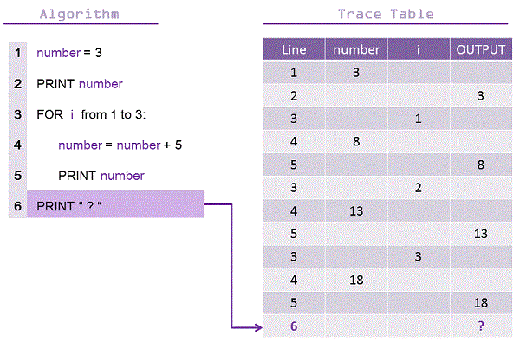

|  |  |  |  |
| --- | --- | --- | --- |
| Line | Number | i | Output |
|  |  |  |  |
|  |  |  |  |
|  |  |  |  |
|  |  |  |  |
|  |  |  |  |
|  |  |  |  |
|  |  |  |  |
|  |  |  |  |
|  |  |  |  |
|  |  |  |  |
|  |  |  |  |
|  |  |  |  |
|  |  |  |  |
|  |  |  |  |
|  |  |  |  |
|  |  |  |  |
|  |  |  |  |
|  |  |  |  |
|  |  |  |  |